PYTHON ACTIVITY BASED LEARNING
Program Record: Algorithm, Pseudocode, Flowchart, Code and Executed Output
Student Name | K. Geethika
Roll Number | 26001151
Branch | Computer Science and Engineering (CSM-05)
College | Dr. RVR NRIIT Deemed to be University

Introduction
This practical record is based on the ten Python source files in the uploaded GitHub repository. Each program includes its aim, step-by-step algorithm, pseudocode, a flowchart using standard flowchart symbols, the original Python code, sample inputs, and the console output obtained by executing the original source code.
Execution note: The outputs shown were produced by running the uploaded Python source code with the sample inputs listed in each section. Some programs contain no input validation, so use valid positive values when testing.

1. Attendance Eligibility

Aim
Calculate attendance percentage and decide whether the student is eligible.

Algorithm
1. Start
2. Input total classes and attended classes
3. Calculate percentage = attended / total × 100
4. Check whether percentage is at least 75%
5. Print Eligible if true; otherwise print Not eligible
6. Stop

Pseudocode
BEGIN
READ total_classes, attended_classes
percentage ← attended_classes / total_classes × 100
IF percentage ≥ 75 THEN
PRINT Eligible
ELSE
PRINT Not eligible
END IF
END

Standard Flowchart
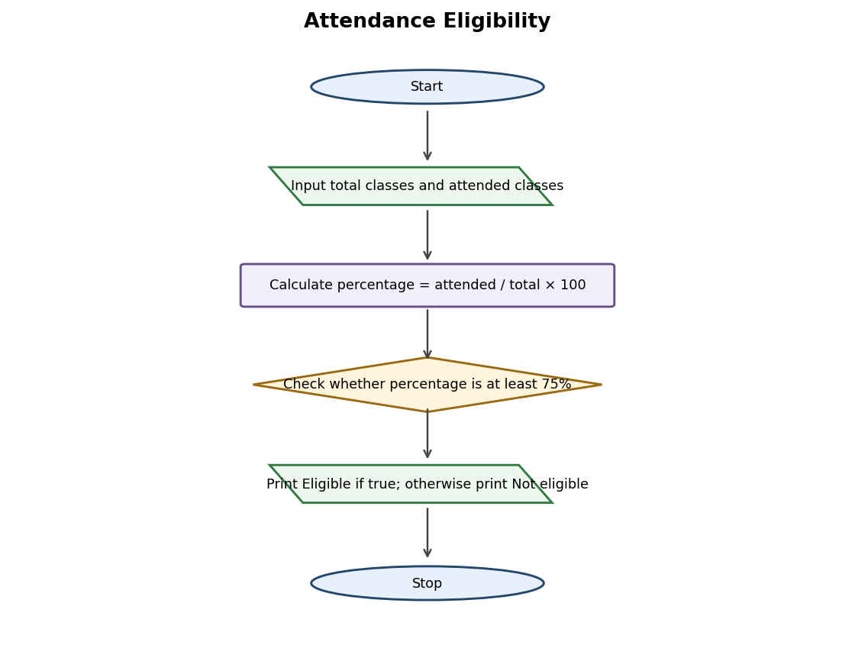
Flowchart symbols: Oval – Start/Stop; parallelogram – Input/Output; rectangle – Process; diamond – Decision; arrows – direction of flow.

Python Code
total = int(input("Enter total classes: "))
attended = int(input("Enter attended classes: "))
percentage = attended / total * 100
print("Attendance:", percentage, "%")
if percentage >= 75:
print("Eligible")
else:
print("Not eligible")

Sample Input
- 40
- 32

Executed Output
Enter total classes: Enter attended classes: Attendance: 80.0 %
Eligible

Result
The attendance eligibility program was executed with the sample input and produced the output shown above.

2. Budget Check

Aim
Check whether expenses are within the fixed budget of Rs. 10,000.

Algorithm
1. Start
2. Set budget to 10000
3. Input expenses
4. Check whether expenses are within budget
5. Print Within budget or Budget exceeded
6. Stop

Pseudocode
BEGIN
budget ← 10000
READ expenses
IF expenses ≤ budget THEN
PRINT Within budget
ELSE
PRINT Budget exceeded
END IF
END

Standard Flowchart
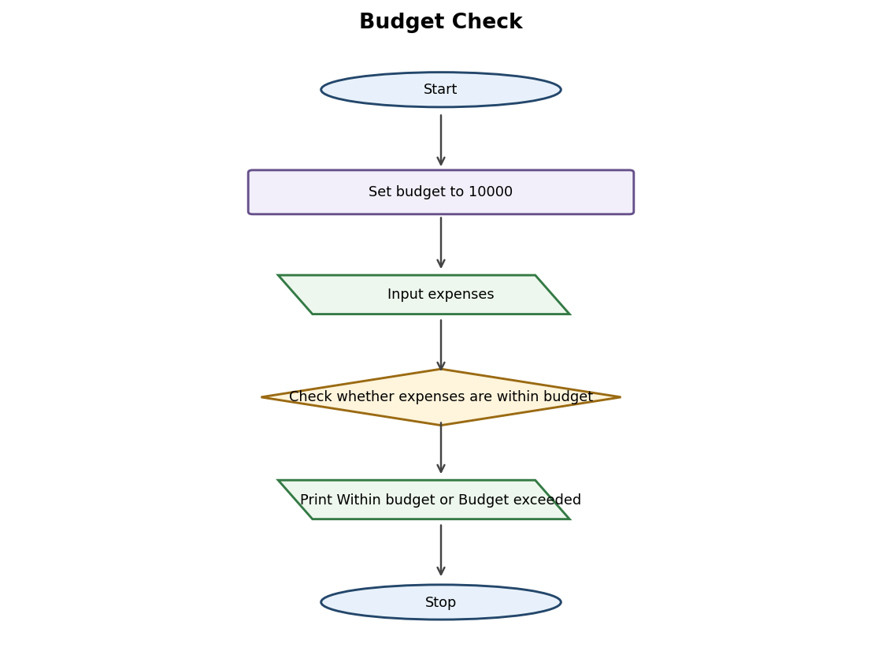
Flowchart symbols: Oval – Start/Stop; parallelogram – Input/Output; rectangle – Process; diamond – Decision; arrows – direction of flow.

Python Code
budget = 10000
expenses = int(input("Enter expenses: "))
if expenses <= budget:
print("Within budget")
else:
print("Budget exceeded")

Sample Input
- 7500

Executed Output
Enter expenses: Within budget

Result
The budget check program was executed with the sample input and produced the output shown above.

3. Fuel Consumption and Cost

Aim
Calculate the fuel required and its cost for a given journey.

Algorithm
1. Start
2. Input distance, mileage and fuel price
3. Calculate fuel = distance / mileage
4. Calculate cost = fuel × fuel price
5. Display fuel required and fuel cost
6. Stop

Pseudocode
BEGIN
READ distance, mileage, fuel_price
fuel ← distance / mileage
cost ← fuel × fuel_price
PRINT fuel, cost
END

Standard Flowchart
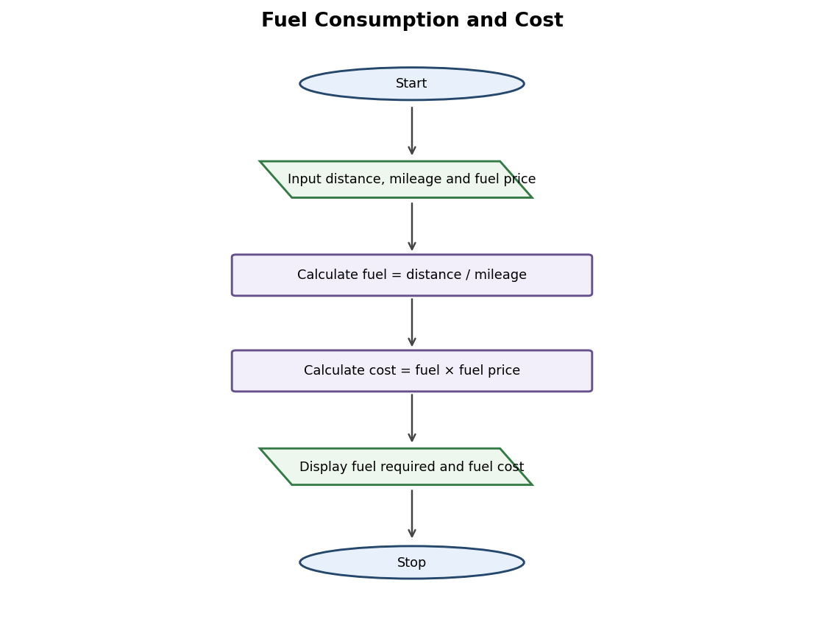
Flowchart symbols: Oval – Start/Stop; parallelogram – Input/Output; rectangle – Process; diamond – Decision; arrows – direction of flow.

Python Code
distance = int(input("Enter distance in km: "))
mileage = int(input("Enter mileage: "))
price = int(input("Enter fuel price: "))
fuel = distance / mileage
cost = fuel * price
print("Fuel required:", fuel)
print("Fuel cost:", cost)

Sample Input
- 150
- 15
- 100

Executed Output
Enter distance in km: Enter mileage: Enter fuel price: Fuel required: 10.0
Fuel cost: 1000.0

Result
The fuel consumption and cost program was executed with the sample input and produced the output shown above.

4. Total Salary Calculation

Aim
Add basic salary and allowance to calculate the total salary.

Algorithm
1. Start
2. Input basic salary and allowance
3. Calculate total salary = basic salary + allowance
4. Display total salary
5. Stop

Pseudocode
BEGIN
READ basic_salary, allowance
total_salary ← basic_salary + allowance
PRINT total_salary
END

Standard Flowchart
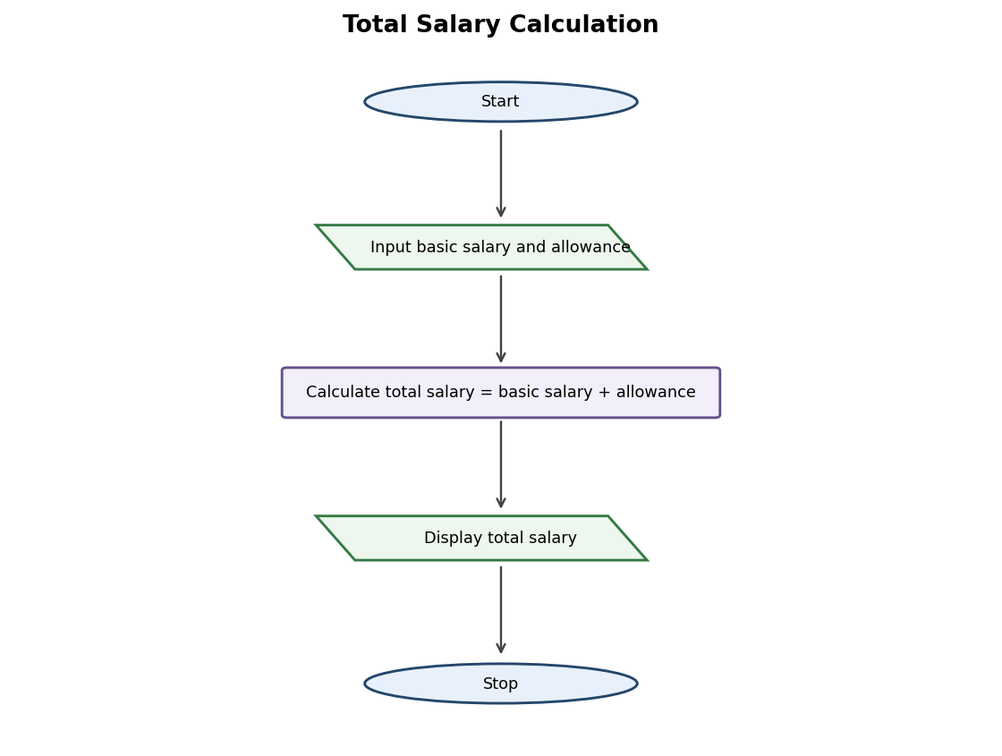
Flowchart symbols: Oval – Start/Stop; parallelogram – Input/Output; rectangle – Process; diamond – Decision; arrows – direction of flow.

Python Code
basic = int(input("Enter basic salary: "))
allowance = int(input("Enter allowance: "))
salary = basic + allowance
print("Total salary:", salary)

Sample Input
- 20000
- 5000

Executed Output
Enter basic salary: Enter allowance: Total salary: 25000

Result
The total salary calculation program was executed with the sample input and produced the output shown above.

5. Electricity Bill Calculation

Aim
Calculate the electricity bill at Rs. 5 per unit.

Algorithm
1. Start
2. Input electricity units
3. Calculate bill = units × 5
4. Display electricity bill
5. Stop

Pseudocode
BEGIN
READ units
bill ← units × 5
PRINT bill
END

Standard Flowchart
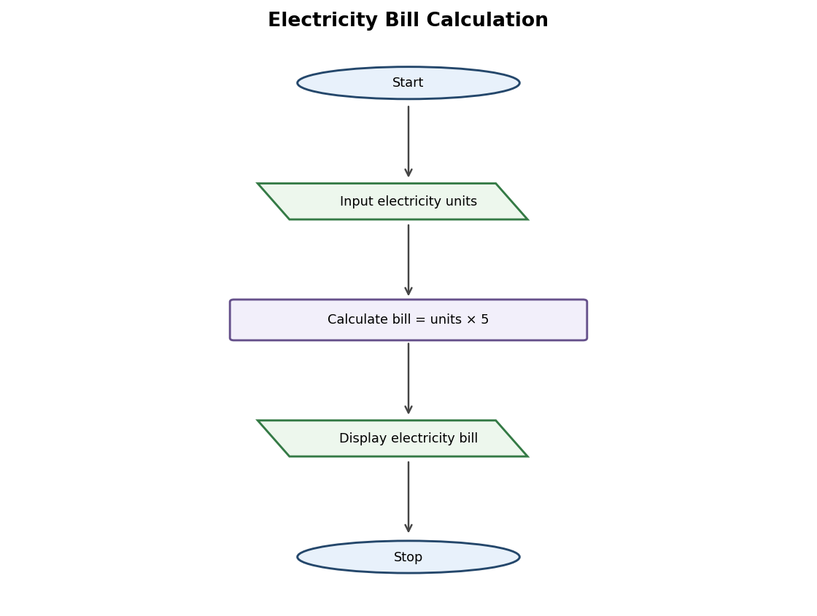
Flowchart symbols: Oval – Start/Stop; parallelogram – Input/Output; rectangle – Process; diamond – Decision; arrows – direction of flow.

Python Code
units = int(input("Enter units: "))
bill = units * 5
print("Electricity bill:", bill)

Sample Input
- 120

Executed Output
Enter units: Electricity bill: 600

Result
The electricity bill calculation program was executed with the sample input and produced the output shown above.

6. Library Fine Calculation

Aim
Calculate the library fine at Rs. 2 for each late day.

Algorithm
1. Start
2. Input number of late days
3. Calculate fine = late days × 2
4. Display library fine
5. Stop

Pseudocode
BEGIN
READ late_days
fine ← late_days × 2
PRINT fine
END

Standard Flowchart
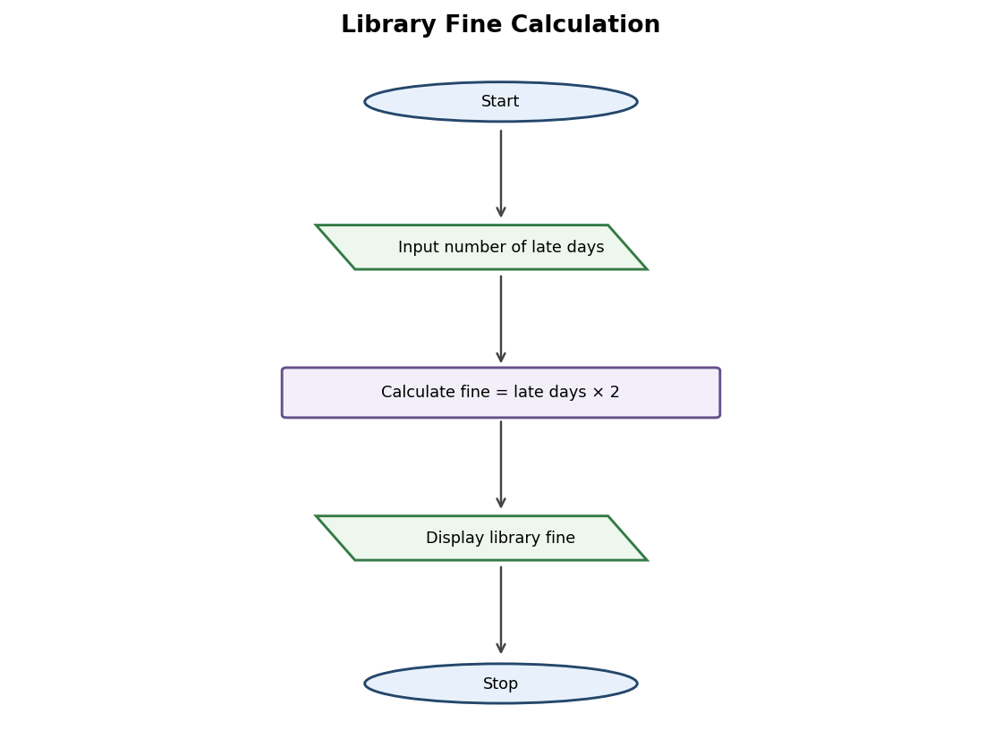
Flowchart symbols: Oval – Start/Stop; parallelogram – Input/Output; rectangle – Process; diamond – Decision; arrows – direction of flow.

Python Code
days = int(input("Enter late days: "))
fine = days * 2
print("Library fine: Rs.", fine)

Sample Input
- 4

Executed Output
Enter late days: Library fine: Rs. 8

Result
The library fine calculation program was executed with the sample input and produced the output shown above.

7. Leftover Meals Calculation

Aim
Find the number of meals left after serving.

Algorithm
1. Start
2. Input prepared meals and served meals
3. Calculate leftover = prepared − served
4. Display leftover meals
5. Stop

Pseudocode
BEGIN
READ prepared, served
leftover ← prepared − served
PRINT leftover
END

Standard Flowchart
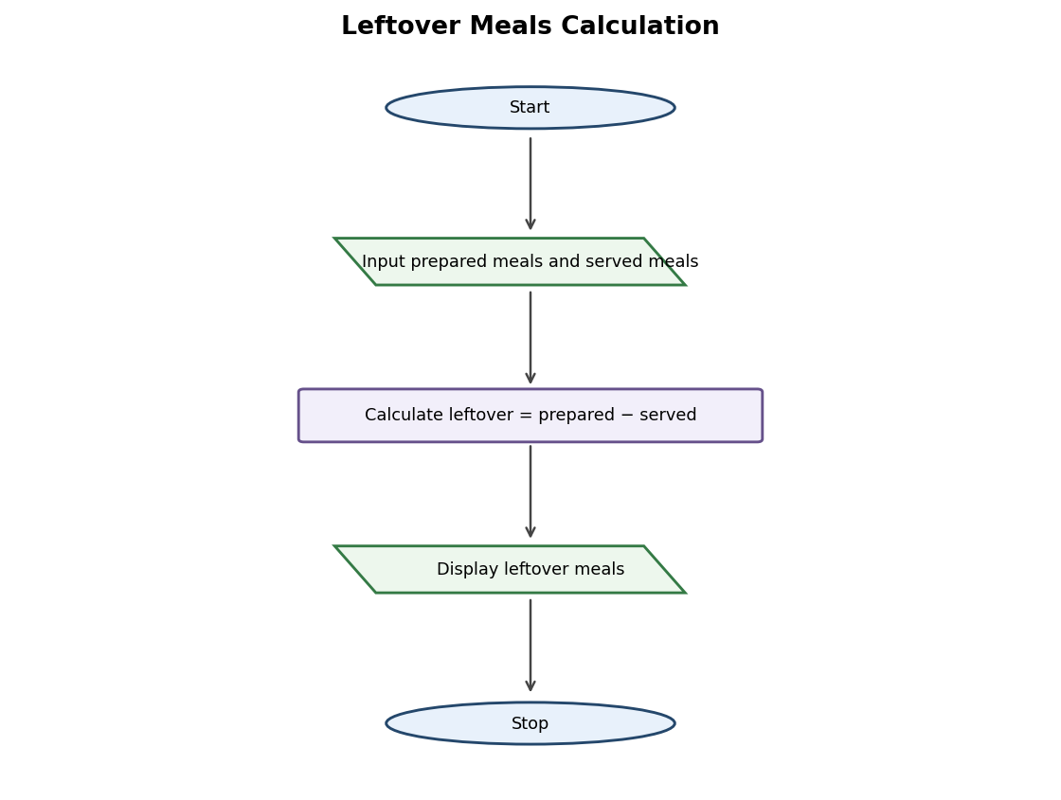
Flowchart symbols: Oval – Start/Stop; parallelogram – Input/Output; rectangle – Process; diamond – Decision; arrows – direction of flow.

Python Code
prepared = int(input("Enter prepared meals: "))
served = int(input("Enter served meals: "))
leftover = prepared - served
print("Leftover meals:", leftover)

Sample Input
- 100
- 85

Executed Output
Enter prepared meals: Enter served meals: Leftover meals: 15

Result
The leftover meals calculation program was executed with the sample input and produced the output shown above.

8. Student Pass or Fail

Aim
Check whether the student scored at least 35 marks in all three subjects.

Algorithm
1. Start
2. Input marks in three subjects
3. Check whether every subject mark is at least 35
4. Print Pass if all conditions are true; otherwise print Fail
5. Stop

Pseudocode
BEGIN
READ m1, m2, m3
IF m1 ≥ 35 AND m2 ≥ 35 AND m3 ≥ 35 THEN
PRINT Pass
ELSE
PRINT Fail
END IF
END

Standard Flowchart
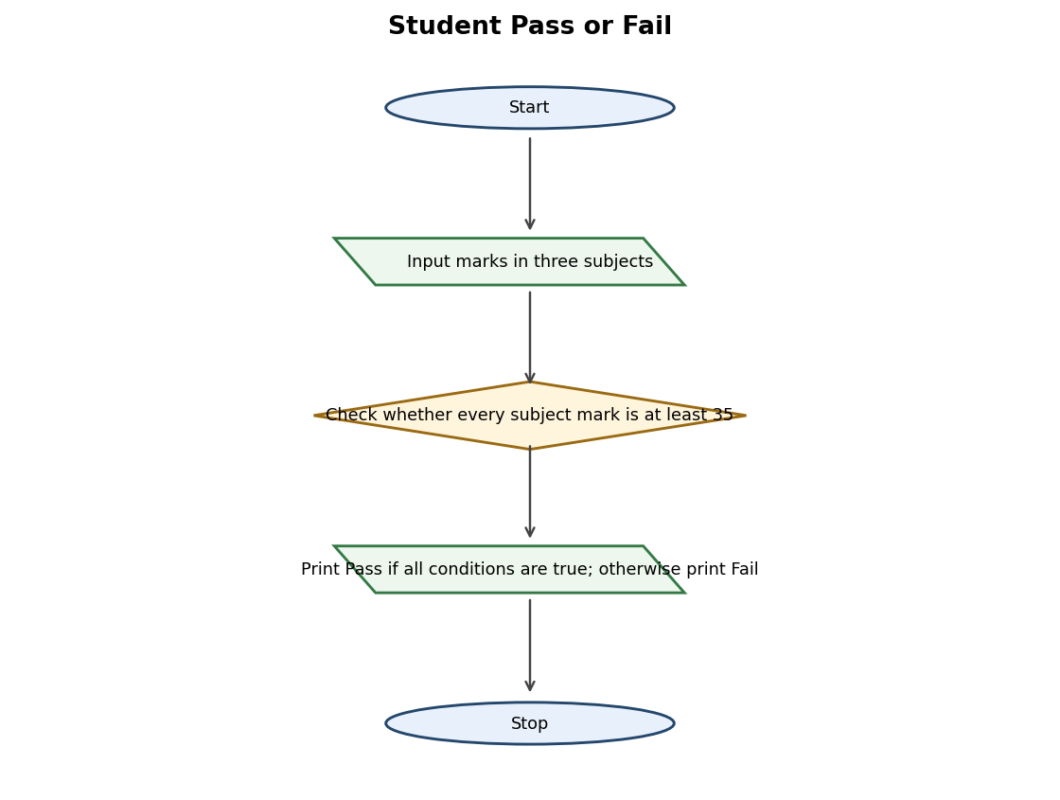
Flowchart symbols: Oval – Start/Stop; parallelogram – Input/Output; rectangle – Process; diamond – Decision; arrows – direction of flow.

Python Code
m1 = int(input("Enter first subject marks: "))
m2 = int(input("Enter second subject marks: "))
m3 = int(input("Enter third subject marks: "))
if m1 >= 35 and m2 >= 35 and m3 >= 35:
print("Pass")
else:
print("Fail")

Sample Input
- 80
- 70
- 65

Executed Output
Enter first subject marks: Enter second subject marks: Enter third subject marks: Pass

Result
The student pass or fail program was executed with the sample input and produced the output shown above.

9. Shopping Budget Check

Aim
Check whether the shopping cost is within the user's budget.

Algorithm
1. Start
2. Input budget and shopping cost
3. Check whether shopping cost is less than or equal to budget
4. Print Shopping is within budget or Budget exceeded
5. Stop

Pseudocode
BEGIN
READ budget, price
IF price ≤ budget THEN
PRINT Shopping is within budget
ELSE
PRINT Budget exceeded
END IF
END

Standard Flowchart
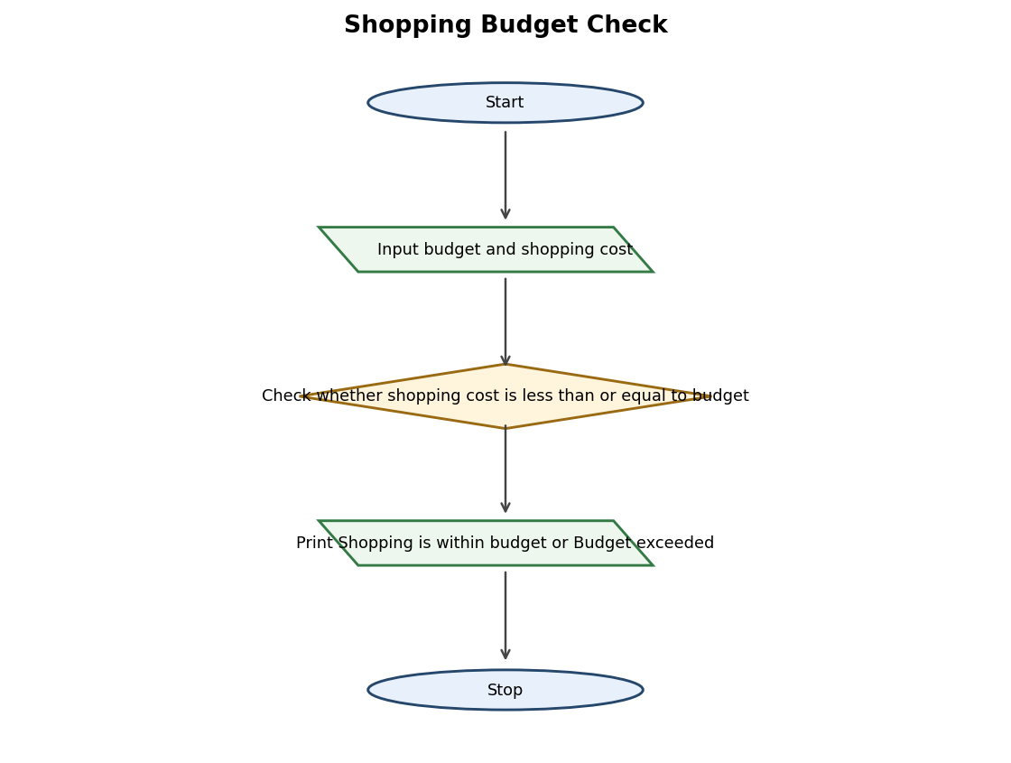
Flowchart symbols: Oval – Start/Stop; parallelogram – Input/Output; rectangle – Process; diamond – Decision; arrows – direction of flow.

Python Code
budget = int(input("Enter your budget: "))
price = int(input("Enter shopping cost: "))
if price <= budget:
print("Shopping is within budget")
else:
print("Budget exceeded")

Sample Input
- 5000
- 3500

Executed Output
Enter your budget: Enter shopping cost: Shopping is within budget

Result
The shopping budget check program was executed with the sample input and produced the output shown above.

10. Bank Deposit and Withdrawal

Aim
Perform a deposit or withdrawal using an initial balance of Rs. 5,000.

Algorithm
1. Start
2. Set balance to 5000
3. Input amount and transaction choice
4. If choice is D, add amount to balance
5. If choice is W, check balance and subtract amount if sufficient; otherwise display Insufficient balance
6. Display final balance
7. Stop

Pseudocode
BEGIN
balance ← 5000
READ amount, choice
IF choice = D THEN
balance ← balance + amount
ELSE IF choice = W THEN
IF amount ≤ balance THEN
balance ← balance − amount
ELSE
PRINT Insufficient balance
END IF
END IF
PRINT balance
END

Standard Flowchart
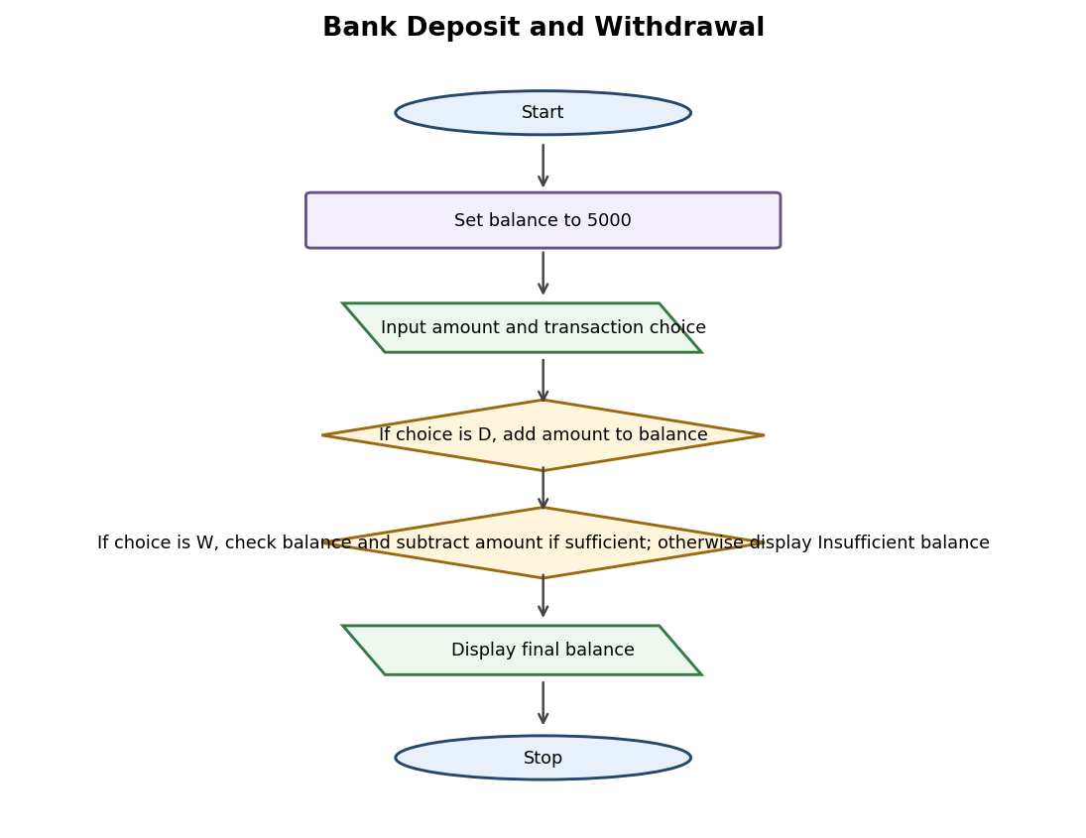
Flowchart symbols: Oval – Start/Stop; parallelogram – Input/Output; rectangle – Process; diamond – Decision; arrows – direction of flow.

Python Code
balance = 5000
amount = int(input("Enter amount: "))
choice = input("Enter D for deposit or W for withdrawal: ")
if choice == "D":
balance = balance + amount
elif choice == "W":
if amount <= balance:
balance = balance - amount
else:
print("Insufficient balance")
print("Final balance:", balance)

Sample Input
- 1000
- D

Executed Output
Enter amount: Enter D for deposit or W for withdrawal: Final balance: 6000

Result
The bank deposit and withdrawal program was executed with the sample input and produced the output shown above.

